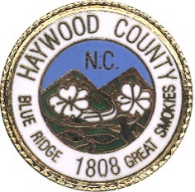

Board of Commissioners County Manager
Bryant Morehead

L. Kevin Ensley, Chairman
Brandon C. Rogers, Vice Chairman County Attorney Tommy Long Frank Queen
Jennifer M. Best
Terry Ramey

NOTICE OF SPECIAL MEETING
HAYWOOD COUNTY GREENWAY COUNCIL
FEBRUARY 17TH, 2026

TAKE NOTICE that the Haywood County Greenway Council will hold a Special Meeting to replace to the regular scheduled Greenway Council meeting beginning at 2 PM on Tuesday, February 17th at the Waynesville Recreation Center Multipurpose room located at 550 Vance Street, Waynesville NC, 28786.

The purpose of the meeting is to discuss the future of the greenway within Haywood County, ongoing projects and member updates.

This is the 16th day of February 2026.

Elli Flagg
Recreation & Parks Director
Haywood County

215 North Main Street • Waynesville, North Carolina 28786
Phone: 828.452.6625 • Fax: 828.452.6715

